**Nama :Satriyo Yudha**

**Kelas :T3I**

**NIM :233140707111082**

**MODUL 6**

**6.3 Latihan**

**1. Buat aplikasi sederhana yang menggunakan TextField untuk mengambil input dari pengguna dan tampilkan input tersebut dalam Text di bawahnya. Gunakan callback onChanged untuk memperbarui teks secara real-time.**

import 'package:flutter/material.dart';

void main() {

runApp(const MyApp());

}

class MyApp extends StatelessWidget {

const MyApp({super.key});

@override

Widget build(BuildContext context) {

return MaterialApp(

home: Scaffold(

appBar: AppBar(title: const Text("TextField Real-time Update")),

body: InputTextWidget(),

),

);

}

}

class InputTextWidget extends StatefulWidget {

@override

_InputTextWidgetState createState() => _InputTextWidgetState();

}

class _InputTextWidgetState extends State<InputTextWidget> {

String _inputText = '';

@override

Widget build(BuildContext context) {

return Padding(

padding: const EdgeInsets.all(16.0),

child: Column(

mainAxisAlignment: MainAxisAlignment.center,

children: <Widget>[

TextField(

decoration: const InputDecoration(labelText: 'Masukkan teks'),

onChanged: (text) {

setState(() {

_inputText = text;

});

},

),

const SizedBox(height: 20),

Text('Teks yang diinput: $_inputText'),

],

),

);

}

}

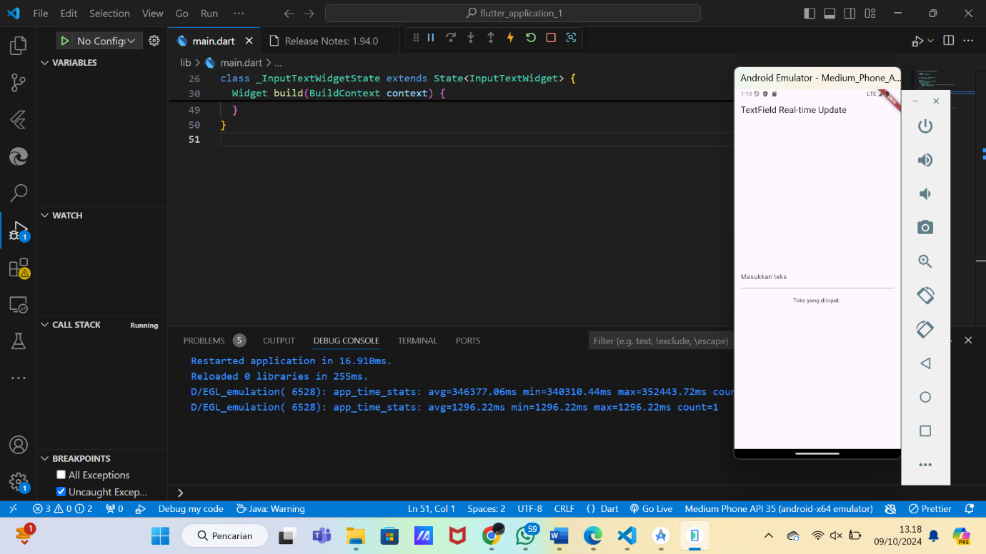

**2. Buat aplikasi dengan DropdownButton yang memungkinkan pengguna memilih dari beberapa opsi, lalu tampilkan opsi yang dipilih di layar. Gunakan callback onChanged untuk memperbarui tampilan.**

import 'package:flutter/material.dart';

void main() {

  runApp(const MyApp());

}

class MyApp extends StatelessWidget {

  const MyApp({super.key});

  @override

  Widget build(BuildContext context) {

    return MaterialApp(

      home: Scaffold(

        appBar: AppBar(title: const Text("Dropdown Pilihan")),

        body: DropdownWidget(),

      ),

    );

  }

}

class DropdownWidget extends StatefulWidget {

  @override

  _DropdownWidgetState createState() => _DropdownWidgetState();

}

class _DropdownWidgetState extends State<DropdownWidget> {

  final List<String> _options = ['Laki - laki', 'Perempuan', 'NONE'];

  String _selectedOption = 'Laki - laki';

  @override

  Widget build(BuildContext context) {

    return Padding(

      padding: const EdgeInsets.all(16.0),

      child: Column(

        mainAxisAlignment: MainAxisAlignment.center,

        children: <Widget>[

          DropdownButton<String>(

            value: _selectedOption,

            items: _options.map((String value) {

              return DropdownMenuItem<String>(

                value: value,

                child: Text(value),

              );

            }).toList(),

            onChanged: (newValue) {

              setState(() {

                _selectedOption = newValue!;

              });

            },

          ),

          const SizedBox(height: 20),

          Text('Opsi yang dipilih: $_selectedOption'),

        ],

      ),

    );

  }

}

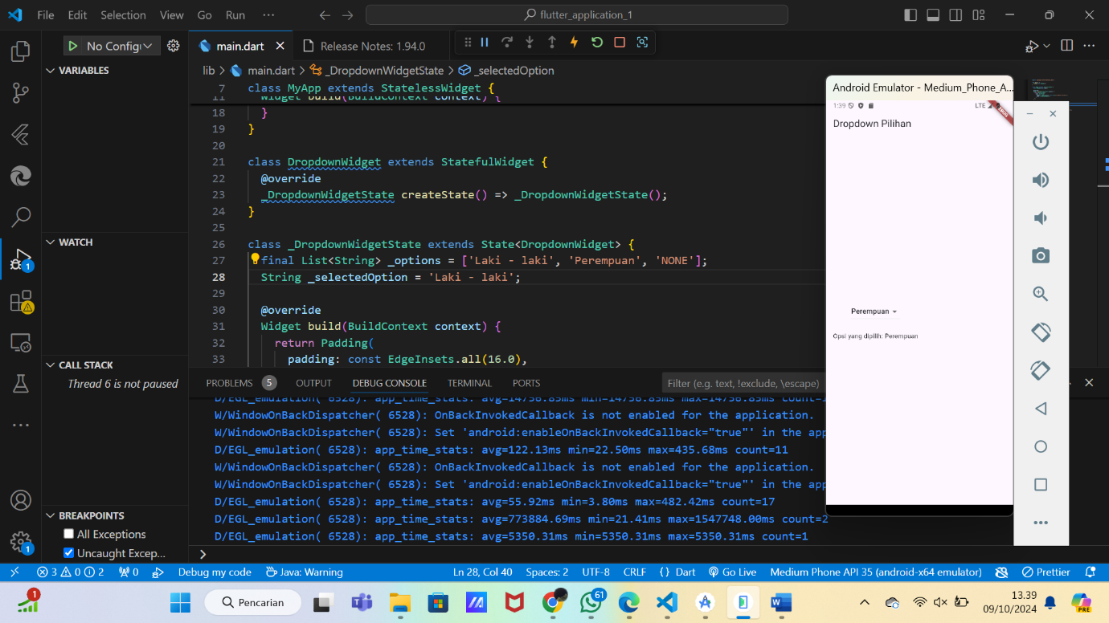

**3. Coba gabungkan beberapa widget input seperti TextField, Slider, dan Switch dalam satu form dan gunakan callback untuk menangani interaksi pengguna.**

import 'package:flutter/material.dart';

void main() {

runApp(const MyApp());

}

class MyApp extends StatelessWidget {

const MyApp({super.key});

@override

Widget build(BuildContext context) {

return MaterialApp(

home: Scaffold(

appBar: AppBar(title: const Text("Form Input Gabungan")),

body: InputFormWidget(),

),

);

}

}

class InputFormWidget extends StatefulWidget {

@override

_InputFormWidgetState createState() => _InputFormWidgetState();

}

class _InputFormWidgetState extends State<InputFormWidget> {

String _name = '';

double _sliderValue = 50;

bool _switchValue = false;

@override

Widget build(BuildContext context) {

return Padding(

padding: const EdgeInsets.all(16.0),

child: Column(

mainAxisAlignment: MainAxisAlignment.center,

children: <Widget>[

TextField(

decoration: const InputDecoration(labelText: 'Nama'),

onChanged: (text) {

setState(() {

_name = text;

});

},

),

const SizedBox(height: 20),

Slider(

value: _sliderValue,

min: 0,

max: 100,

onChanged: (newValue) {

setState(() {

_sliderValue = newValue;

});

},

),

const SizedBox(height: 20),

Switch(

value: _switchValue,

onChanged: (newValue) {

setState(() {

_switchValue = newValue;

});

},

),

const SizedBox(height: 20),

ElevatedButton(

onPressed: () {

print('Nama: $_name, Nilai Slider: $_sliderValue, Switch: $_switchValue');

},

child: const Text('Submit'),

),

],

),

);

}

}

